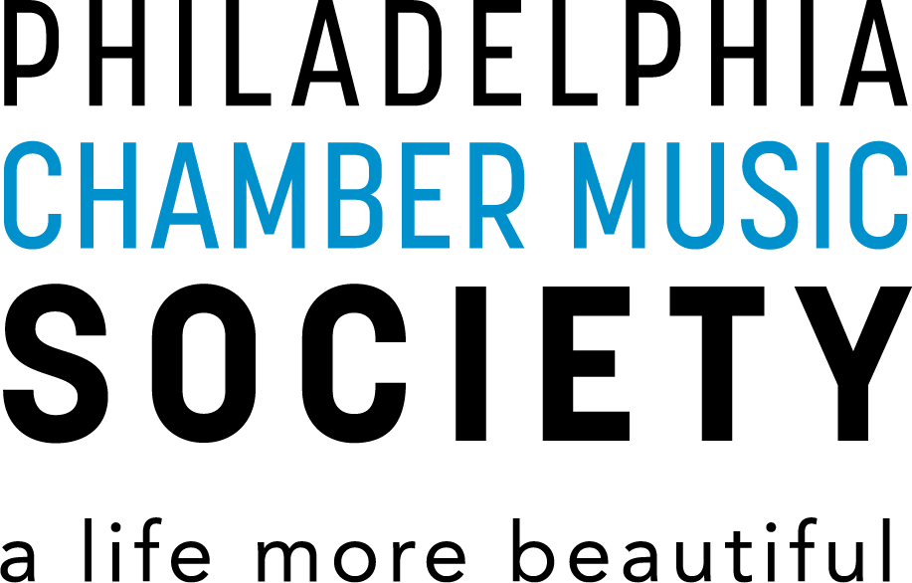
PREVIEW
NOTES

Davóne Tines, bass-baritone
John Bitoy, piano
Tuesday, February 28 – 7:30 PM
Perelman Theater, Kimmel Center

PROGRAM

Recital #1: Mass is an exploration of the Mass woven through Western European, African American, and 21st Century traditions featuring works by Johann Sebastian Bach (1685-1750), Julius Eastman (1940-1990), Caroline Shaw (b. 1982), and Tyshawn Sorey (b. 1980), and spirituals by Moses Hogan (1957-2003) and Margaret Bonds (1913-1972). Says Tines, “The ritualistic template of the Mass is a proven structure—centuries of culture have upheld it. Anything that I put into it will assume a certain shape. And what I put into it is my own lived experience.”

